GitHub: KhanhTaiTran/Web-Application-Lab
Output:
http://localhost:8080/products
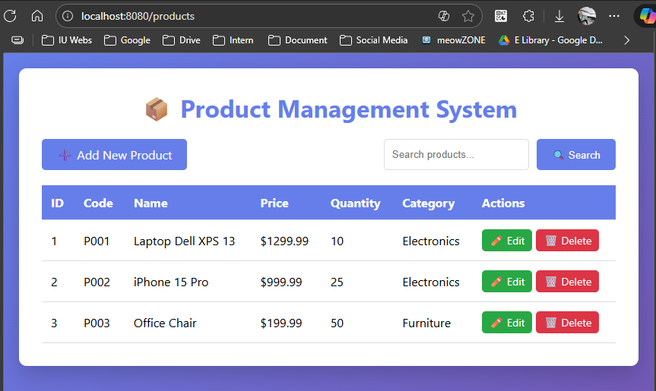
Search product:
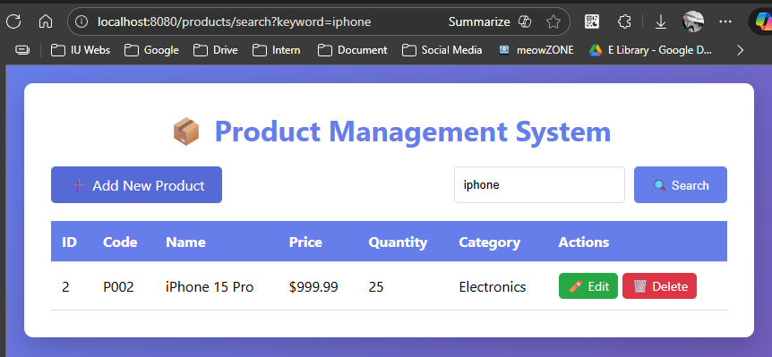

Add new product form:
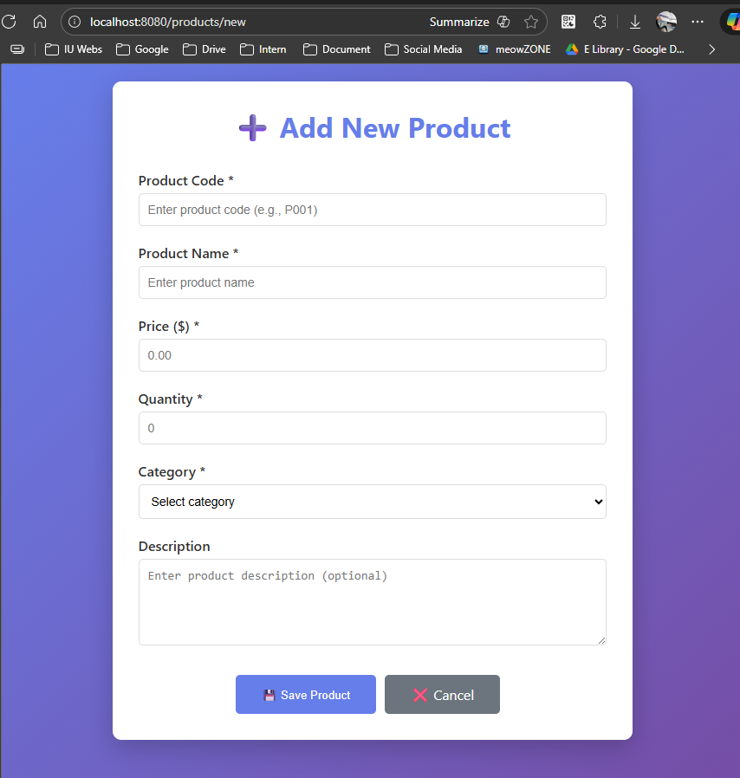

Edit form :
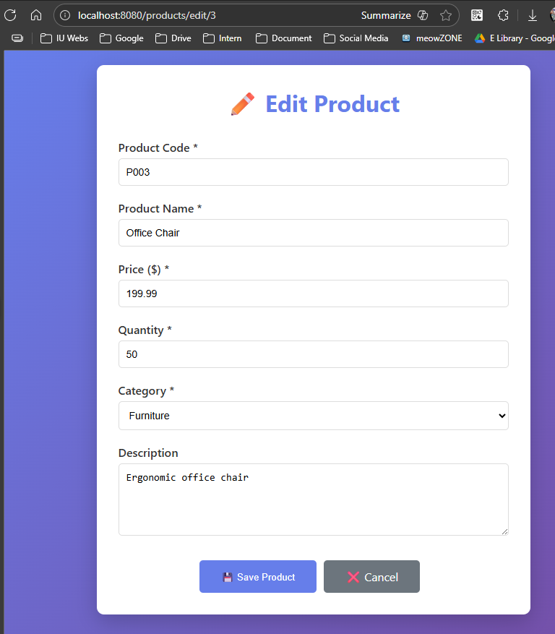

Delete product
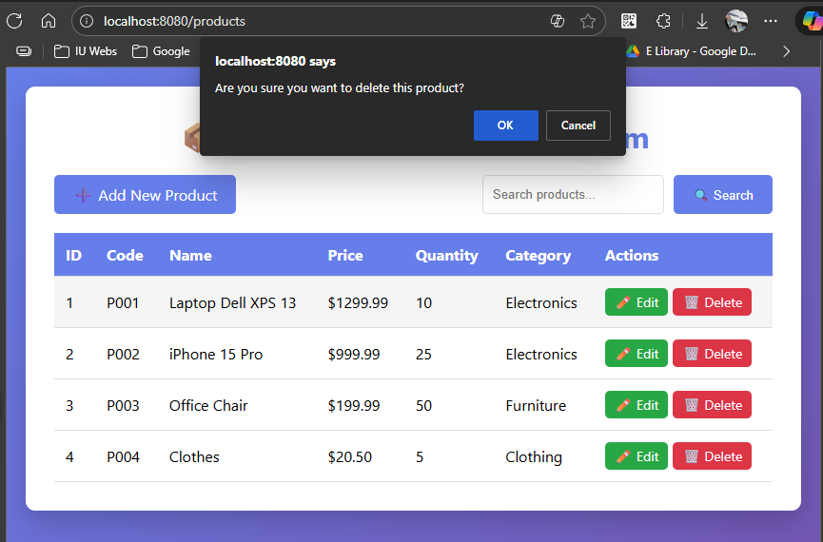
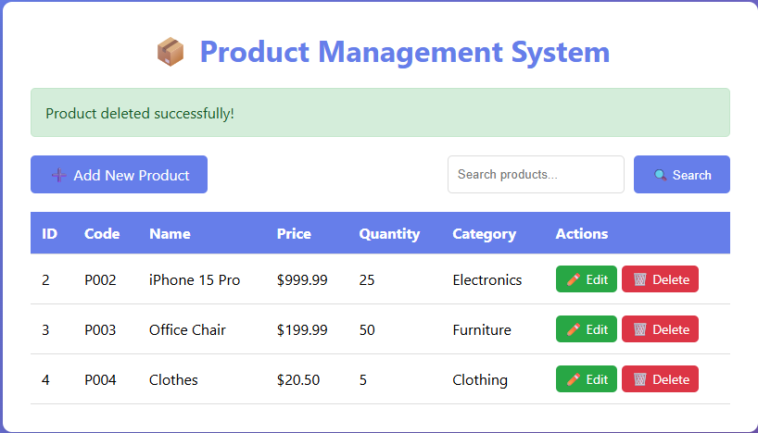

Task 2.3: Test Repository:
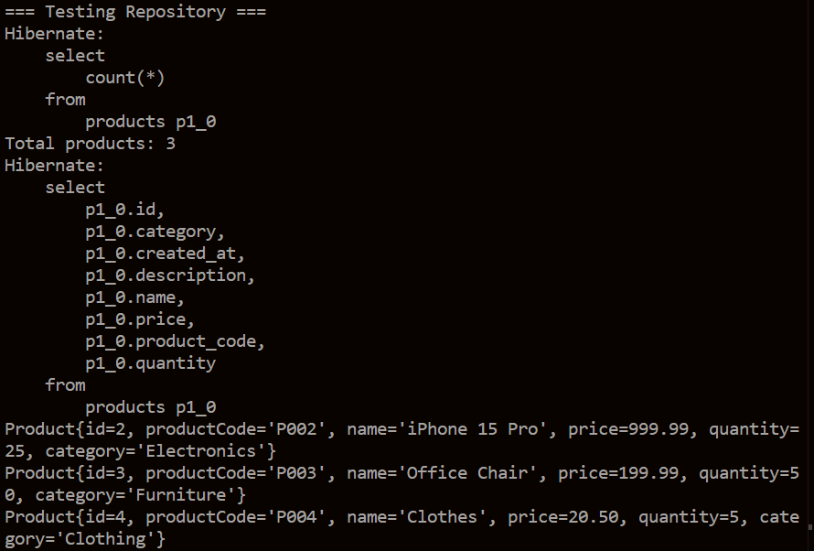
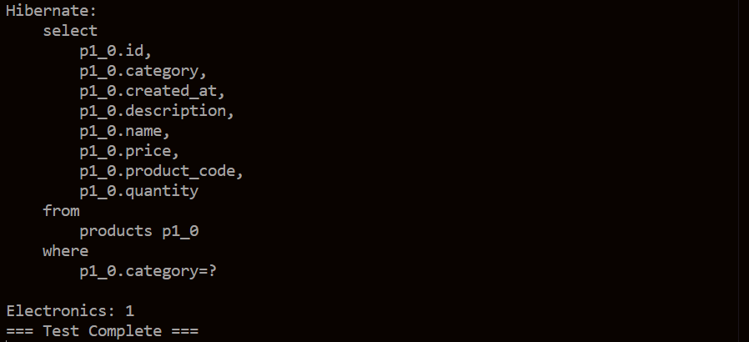

Explain: Request flow
User clicks “View Products”:
- Browser → GET /products
- ProductController receives request (@GetMapping)
- Controller calls productService.getAllProducts()
- Service calls productRepository.findAll()
- JPA automatically queries database
- Repository returns List<Product>
- Controller adds data to Model
- Returns view name "product-list"
- Thymeleaf renders HTML
- Response sent to browser
User “Create an Product”:
- Browser -> GET/products/new
- ProductController receives request (@GetMapping(“/new”))
- Add it to model
- Controller create new empty product object of the Product Class (to create new product)
- Render HTML with empty form
- Response to the client (add new product page)
- Fill form and click Save Product button
- Browser -> POST/products/save
- Controller receives POST (@PostMapping(“/save”))
- Spring binds form data to Product object via @ModelAttribute
- Then Controller call saveProduct function from ProductService class
- Service call Service Implementation
- JPA auto queries DB
- Controller ass success message
- Return redirect: Browser redirect to product list + show updated list with new product
User “Update product”
- Browser -> GET/products/edit/{id}
- Controller receives request (@GetMapping("/edit/{id}"))
- Controller call productService.getProductById()
- Service call producRepository.findById()
- JPA auto execute
- Controller use optional
  - If found: add product to model -> return product-form
  - If not: add error msg, redirect to /products
- Click save btn, Browser -> POST/products/save
- Controller receives POST (@PostMapping(“/save”))
- Bind form data to Product objec via @ModelAttribute
- Then productService.saveProduct() function
  - This function call the saveProduct function in ProductServiceImp class
  - Then it call to the producRepository.save() function
- JPA automatically execute queries
- Controller pass success msg
- Return: redirect to product list + show updated list.
Delete:
- Browser -> GET/products/delete/{id}
- Controller receives request
  - @PathVariable Long id : extracts ID from URL
- Controller call productService.deleteProduct(id)
- Service call Service Implementation
- Service Implementation call Product Repository
- JPA execute
- Controller add success msg
- Return: redirected to the product list
Search :
- Browser -> GET/products/search?keyword=?
- Controller receives request
  - @RequestParam(“keyword”) : extracts search term
- Controller call productService.searchProducts() ->
- Service call repository
- JPA execute
- return a List of products
- Controller add to model:
  - Products – search result
  - Keyword – to display in search box
- Return to view product-list
- Thymeleaf renders product-list.html
- Repsonse to the browser

